Network Music Festival presents a weekend of cutting edge hi-tech digital music on 26th - 28th September

For immediate release: 11th September

Network Music Festival explores the impact of internet technology on musical creation and performance practice with a weekend of innovative musical performances, installations, workshops and talks.

The Network Music Festival (NMF) presents a hi-tech weekender of musical performances, installations, art and workshops investigating the impact of networking technology on musical creation and performance.

Now in its third year, the festival brings together communities of artists and researchers in venues around Birmingham’s creative and digital quarter Digbeth along with leading performers and artists from around the world.

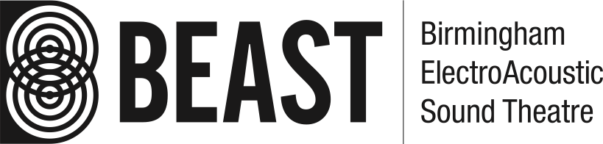
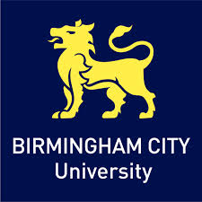


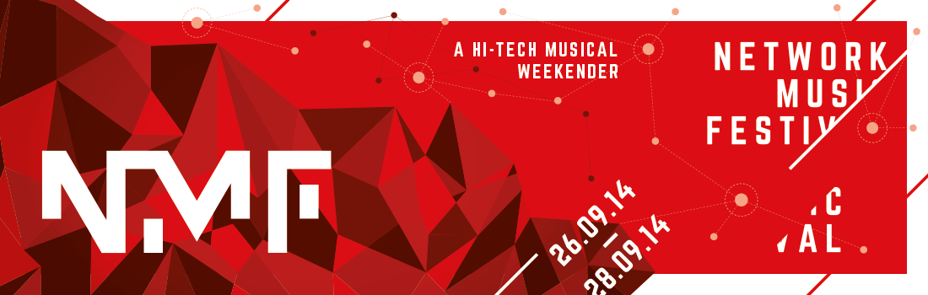
The main theme for 2014 is collaboration through online environments and networked live coding*, exploring the aesthetics, performance practice and technologies around topics such as multi-location performance, web-streaming, collaborative live coding environments, interactive participatory activities and more.

Highlights include a number of free talks, as well as performances from artists including:

*Clamour, who will invite audience members to become co-composers of their performance through a browser based game on their mobile phones;;

*Hugs Bison, who will run a workshop and performance for any number of participants in which anyone of any skill level is invited to participate. A graphic score will be generated live and participants in Birmingham and in remote locations will play along with it while streaming the result to other players.

*Canute, who will give a live-code performance of algorithmic dance music.

NMF is also delighted to be launching its first collaboration with the Live Code Research Network, who are bringing leading live coding experts and performers to the city for their symposium on ‘Live coding in collaboration and network music’ at the University of Birmingham on 25-26th September 2014. We’ll be celebrating this partnership by exploring the symposium topics through special live coding performance events throughout the weekend including a full-on code-fuelled Algorave** on Friday 26th September.

The festival will take place 26-28th September 2014 in Birmingham, across a number of the city’s most hi-tech performance spaces: University of Birmingham’s BEASTdome, 30-channel sound projection performance space; and Birmingham City University’s purpose built media centre at The Parkside building.

Tickets are available now from Brown Paper Tickets.

Organisers: Shelly Knotts, Charles Celéste Hutchins, Holger Ballweg, Jonas Hummel, Antonio Roberts.

For further information or comment, please contact Charles Hutchins on 07908 255 439 or networkmusicfestival@gmail.com

Notes for editors:
Tickets are £10-12 (£8-10 concs) for a day pass or £30 (£25 concs) for a weekend pass including all events and concerts. They are available now on networkmusicfestival14.brownpapertickets.com.

Further line-up details and information is available at the festival website, http://networkmusicfestival.org/

*Live coding is a new direction in electronic music and video: live coders expose and rewire the innards of software while it generates improvised music and/or visuals. All code manipulation is projected for your pleasure. http://toplap.org/about/

**Algoraves embrace the alien sounds of raves from the past, and introduce alien, futuristic rhythms and beats made through strange, algorithm-aided processes. Using systems built for creating algorithmic music, musicians are able to compose and work live with their music as algorithms. It’s up to the good people on the dancefloor to help the musicians make sense of this and do the real creative work in making a great party. http://algorave.com/about/

Festival Schedule:

Friday 26th September

BEASTdome, Bramhall Building, University of Birmingham, B15 2TT
6pm // Multichannel Concert

Unplug, Digbeth High Street
10pm // Algorave

Saturday 27th September

The Parkside Building, Birmingham City University, 5 Cardigan Street, B4 7BD
11am // Networked Graphic Scores Workshop

The Shell, The Parkside Building, Birmingham City University, 5 Cardigan Street, B4 7BD
2pm // Grande Internationale Audio Streaming Orchestra

5pm // Hugs Bison - Cappricio for Network Performers

6pm // Graphic Scores Concert

Stryx, 13 Minerva Works, Digbeth
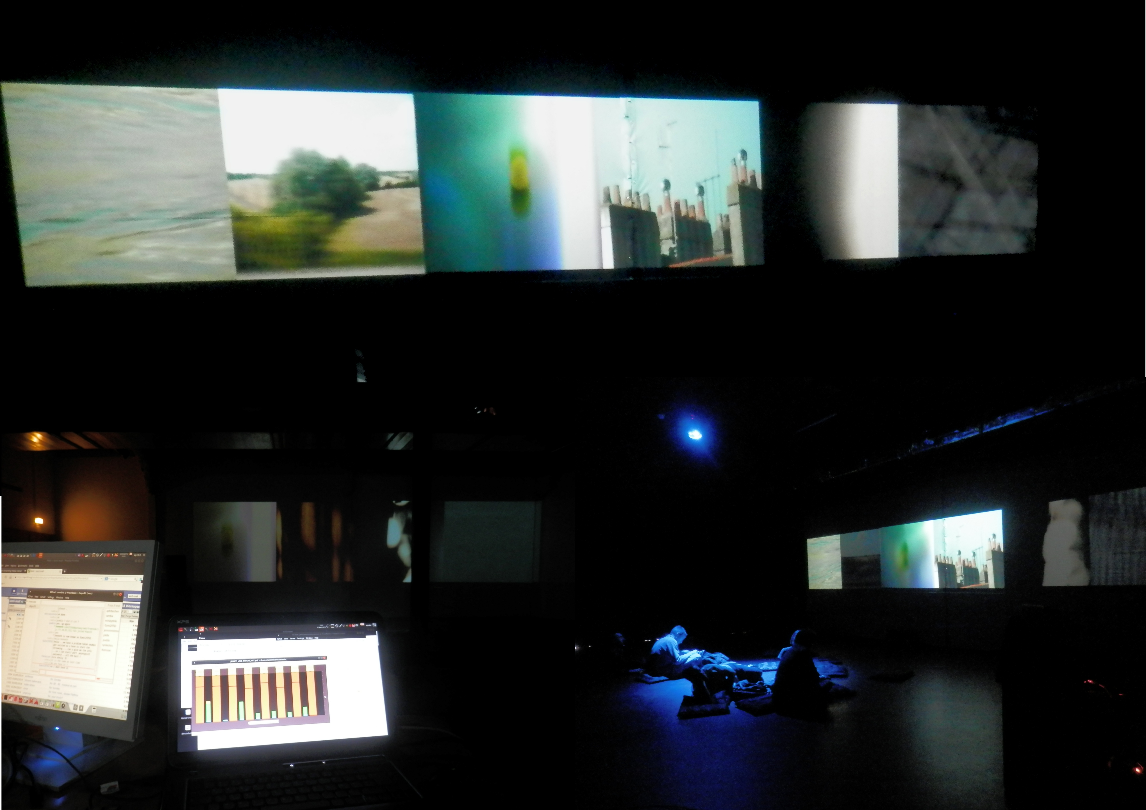
9.30pm // Late Night Concert

Saturday 27th September

The Parkside Building, Birmingham City University, 5 Cardigan Street, B4 7BD
10am // TinySC workshop

Venue TBC
11am // Artists Talks

The Shell, The Parkside Building, Birmingham City University, 5 Cardigan Street, B4 7BD
2pm // Collaborative Live Coding Performances

5pm // LaptopsRus - CRISISRUS performance

6pm // Closing Concert



